|  |  |
| --- | --- |
|  | **Indiana University** |
|  | *Interpreting regression models using Stata*  Scott Long  August 13, 2013  Draft: Long-StataCorp-2013-08-07.docx |

# Interpreting regression models

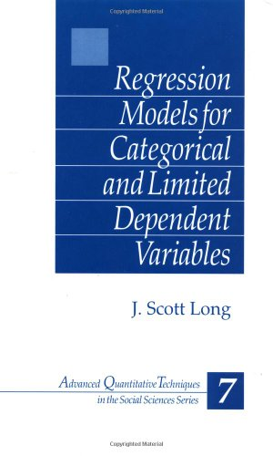  
1980s Interpreting log-linear and multinomial   
 models to support substantive research

1991 *Markov: A Statistical Environment for GAUSS*

1996 change.ado and genpred.ado in Stata 4

1997 *Regression Models for Categorical and Limited   
 Dependent Variables*

1997 *Markov 2.5*

# Working with StataCorp

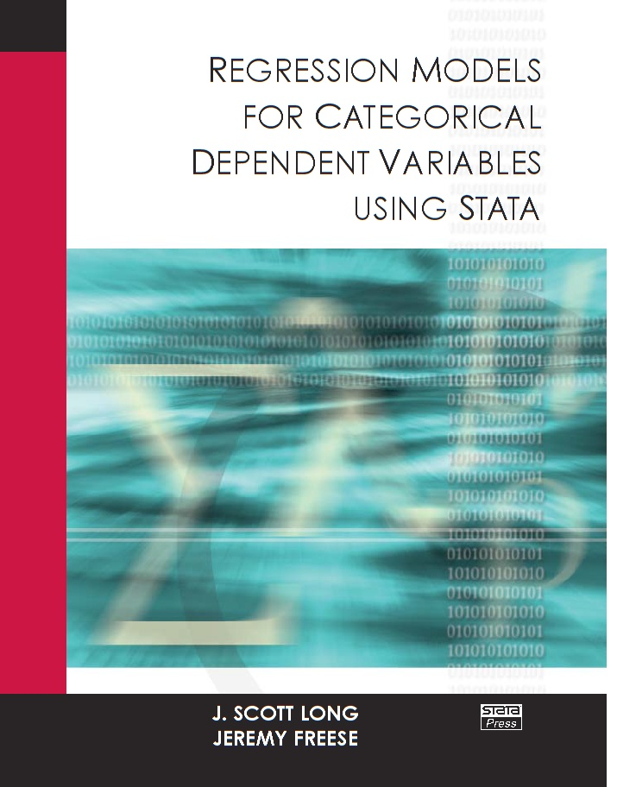1998 Bill Sribney on post-estimation  
 Bill Gould on returns

1999 SPost with Jeremy Freese

2000 David Drukker and StataPress

2001 *Regression Models for Categorical   
 Dependent Variables with Stata*  
 with Jeremy Freese.

# Continuing work...

2005 *Regression Models with Stata, 2nd*

2005 SPost9 20,000 downloads.

2008 *The Workflow of Data Analysis using Stata*

2009 Stata 11 and margins and factor variables.

2011 Stata 12 with marginsplot

2012 SPost13 for 3rd edition

2013 Stata 13

# Stata at Indiana

My students appeared in class wearing...



# Goals for visiting StataCorp

## Demo SPost13 wrappers for margins

* Did we miss something? Are there better ways to do things?
* Do our new methods of interpretation make sense?

## Other SPost13 commands

* Why we wrote them
* Why StataCorp might want to improve them

## Things we'd like to see in Stata

# Interpretation using predictions

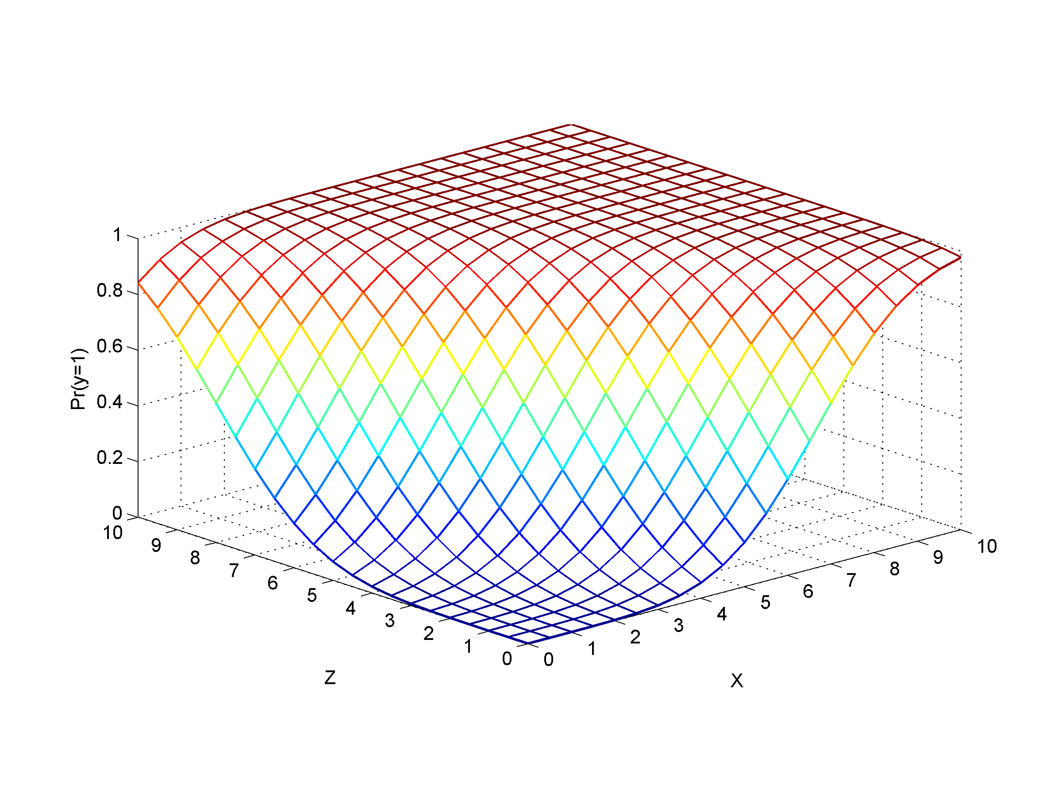

With multiple outcomes and K predictors...

## Interpreting nonlinear models

1. Requires functions of parameters.

2. Requires the observed data.

## Ways to use predictions

Tables: Predictions at multiple levels of regressors.

Marginal effects: Changes in predictions.

Graphs: Predictions at many levels of regressors.

# The tools

## Official Stata

margins

marginsplot

## SPost13 wrappers for margins and lincom

mtable: tables of predictions

mchange: marginal effects

mgen: predictions to plot

mlistat: compact at() matrix listing

mlincom: tables of linear combinations (wrapper for lincom)

## Why not simply use margins and marginsplot?

# Tables of predictions

Predictions at substantively informative values of regressors.

## Binary outcome

sysuse binlfp4, clear

logit lfp k5 k618 i.agecat i.wc i.hc lwg inc

#### Question

How does the number of children and a woman's education affect labor force participation?

#### margins

. margins, atmeans at(wc=(0 1) k5=(0 1 2 3))

Adjusted predictions Number of obs = 753

Model VCE : OIM

Expression : Pr(lfp), predict()

1.\_at : wc = 0

k5 = 0

k618 = 1.353254 (mean)

1.agecat = .3957503 (mean)

2.agecat = .3851262 (mean)

3.agecat = .2191235 (mean)

0.hc = .6082337 (mean)

1.hc = .3917663 (mean)

lwg = 1.097115 (mean)

inc = 20.12897 (mean)

2.\_at : wc = 0

:::snip:::

3.\_at : wc = 0

:::snip:::

4.\_at : wc = 0

:::snip:::

5.\_at : wc = 1

:::snip:::

6.\_at : wc = 1

:::snip:::

7.\_at : wc = 1

:::snip:::

8.\_at : wc = 1

:::snip:::

------------------------------------------------------------------------------

| Delta-method

| Margin Std. Err. z P>|z| [95% Conf. Interval]

-------------+----------------------------------------------------------------

\_at |

1 | .6035431 .0256741 23.51 0.000 .5532229 .6538633

2 | .2746181 .0359919 7.63 0.000 .2040752 .3451609

3 | .0860471 .0280757 3.06 0.002 .0310198 .1410744

4 | .0228776 .0121605 1.88 0.060 -.0009566 .0467119

5 | .771705 .0349691 22.07 0.000 .7031668 .8402432

6 | .4567078 .0566536 8.06 0.000 .3456687 .5677469

7 | .1729059 .0532296 3.25 0.001 .0685779 .277234

8 | .049419 .025671 1.93 0.054 -.0008953 .0997333

------------------------------------------------------------------------------

#### mtable: simple

. mtable, atmeans at(wc=(0 1) k5=(0 1 2 3)) <= pass through to margins

Expression: Pr(lfp)

| 1.

| wc k5 pr

----------+-----------------------------

1 | 0 0 0.604

2 | 0 1 0.275

3 | 0 2 0.086

4 | 0 3 0.023

5 | 1 0 0.772

6 | 1 1 0.457

7 | 1 2 0.173

8 | 1 3 0.049

Constant values of at() variables

2. 3. 1.

k618 agecat agecat hc lwg inc

-----------------------------------------------------------------

1.353 0.385 0.219 0.392 1.097 20.129

#### mtable: building a table

. qui mtable, atmeans at(wc=0 k5=(0 1 2 3)) estname(NoCol)

. qui mtable, atmeans at(wc=1 k5=(0 1 2 3)) estname(College) ///

> atvars(\_none) right

. mtable, atmeans dydx(wc) at(k5=(0 1 2 3)) estname(Diff) stats(est p) ///

> atvars(\_none) names(columns) right

k5 NoCol College Diff p

------------------------------------------------

0 0.604 0.772 0.168 0.000

1 0.275 0.457 0.182 0.001

2 0.086 0.173 0.087 0.013

3 0.023 0.049 0.027 0.085

## Categorical outcomes

. sysuse ordwarm4, clear

. tab warm

Working mom |

can have |

warm |

relations w |

child? | Freq. Percent Cum.

------------+-----------------------------------

1\_SD | 297 12.95 12.95

2\_D | 723 31.53 44.48

3\_A | 856 37.33 81.81

4\_SA | 417 18.19 100.00

------------+-----------------------------------

Total | 2,293 100.00

. ologit warm i.yr89 i.male i.white age i.edcat prst

#### Question

How do age and gender affect support for working women as mothers?

#### margins

. foreach iout in 1 2 3 4 {

2. margins, at(yr89=(0 1) male=(0 1)) atmeans predict(outcome(`iout'))

3. }

Adjusted predictions Number of obs = 2293

Model VCE : OIM

Expression : Pr(warm==1), predict(outcome(1))

1.\_at : yr89 = 0

:::snip:::

------------------------------------------------------------------------------

| Delta-method

| Margin Std. Err. z P>|z| [95% Conf. Interval]

-------------+----------------------------------------------------------------

\_at |

1 | .0981207 .0074061 13.25 0.000 .083605 .1126365

2 | .1868221 .0117184 15.94 0.000 .1638545 .2097897

3 | .0604381 .0053787 11.24 0.000 .049896 .0709802

4 | .1195914 .0095217 12.56 0.000 .1009293 .1382536

------------------------------------------------------------------------------

Adjusted predictions Number of obs = 2293

Model VCE : OIM

Expression : Pr(warm==2), predict(outcome(2))

:::snip:::

------------------------------------------------------------------------------

| Delta-method

| Margin Std. Err. z P>|z| [95% Conf. Interval]

-------------+----------------------------------------------------------------

\_at |

1 | .3069102 .0125571 24.44 0.000 .2822987 .3315216

2 | .4029306 .0127015 31.72 0.000 .378036 .4278251

3 | .2265499 .0119914 18.89 0.000 .2030473 .2500525

4 | .3398556 .0137531 24.71 0.000 .3129002 .3668111

------------------------------------------------------------------------------

:::snip:::

:::snip:::

#### mtable: quick

. mtable, at(yr89=(0 1) male=(0 1)) atmeans

Expression: Pr(warm)

| 1. 1.

| yr89 male 1 SD 2 D 3 A 4 SA

----------+-----------------------------------------------------------

1 | 0 0 0.098 0.307 0.415 0.180

2 | 0 1 0.187 0.403 0.316 0.094

3 | 1 0 0.060 0.227 0.442 0.271

4 | 1 1 0.120 0.340 0.391 0.150

Constant values of at() variables

1. 2. 3. 4.

white age edcat edcat edcat prst

-----------------------------------------------------------------

0.877 44.935 0.341 0.196 0.171 39.585

#### mtable: building

. qui mtable, at(yr89=0 male=1) atmeans rowname(Men) clear roweq(1977)

. qui mtable, at(yr89=0 male=0) atmeans rowname(Women) below roweq(1977)

. qui mtable, dydx(male) at(yr89=0) atmeans rowname(M-W) below roweq(1977)

. qui mtable, at(yr89=1 male=1) atmeans rowname(Men) below roweq(1989)

. qui mtable, at(yr89=1 male=0) atmeans rowname(Women) below roweq(1989)

. qui mtable, dydx(male) at(yr89=1) atmeans rowname(M-W) below roweq(1989)

. qui mtable, dydx(yr89) at(male=1) atmeans rowname(77to89) below roweq(Men)

. mtable, dydx(yr89) at(male=0) atmeans rowname(77to89) below roweq(Women)

| 1 SD 2 D 3 A 4 SA

----------+---------------------------------------

1977 |

Men | 0.187 0.403 0.316 0.094

Women | 0.098 0.307 0.415 0.180

M-W | 0.089 0.096 -0.099 -0.086

1989 |

Men | 0.120 0.340 0.391 0.150

Women | 0.060 0.227 0.442 0.271

M-W | 0.059 0.113 -0.051 -0.121

Men |

77to89 | -0.067 -0.063 0.075 0.055

Women |

77to89 | -0.038 -0.080 0.027 0.091

Suggestion

1. margins for multiple outcomes

* Joint estimation, not simply accumulation over outcomes

1. Compact summary of at() values.

# Marginal effects

D:\My Box Files\CDA13\Work\figures-new\brm_dc_partial.emf

Mathematically, ...

## Marginal change



## Discrete change



## Binary outcome

sysuse binlfp4, clear

logit lfp k5 k618 i.agecat i.wc i.hc lwg inc

### Question

How to assess the magnitudes of the effects?

#### mchange

. mchange

logit: Changes in Pr(lfp) | N = 753

| Change P>|z|

----------------+----------------------

1.wc |

0 to 1 | 0.1624 0.0002

k5 |

+1 cntr | -0.2818 0.0000

+SD cntr | -0.1503 0.0000

Marginal | -0.2888 0.0000

k618 |

+1 cntr | -0.0136 0.3354

+SD cntr | -0.0180 0.3353

Marginal | -0.0136 0.3354

1.hc |

0 to 1 | 0.0282 0.5076

lwg |

+1 cntr | 0.1260 0.0000

+SD cntr | 0.0742 0.0000

Marginal | 0.1266 0.0000

inc |

+1 cntr | -0.0073 0.0000

+SD cntr | -0.0845 0.0000

Marginal | -0.0073 0.0000

agecat |

40-49 vs 30-39 | -0.1242 0.0017

50+ vs 30-39 | -0.2624 0.0000

50+ vs 40-49 | -0.1382 0.0024

Average predictions

not in LF in LF

Pr(y|base) 0.4316 0.5684

1: Predictions averaged over the sample.

### mchange with options (edited)

. mchange, stats(from to change pvalue)

logit: Changes in Pr(lfp) | N = 753

| From To Change P>|z|

----------------+--------------------------------------------

1.wc |

0 to 1 | 0.5251 0.6875 0.1624 0.0002

k5 |

+1 cntr | 0.7040 0.4222 -0.2818 0.0000

+SD cntr | 0.6420 0.4917 -0.1503 0.0000

Marginal | . . -0.2888 0.0000

inc |

+1 cntr | 0.5720 0.5648 -0.0073 0.0000

+SD cntr | 0.6101 0.5257 -0.0845 0.0000

Marginal | . . -0.0073 0.0000

agecat |

40-49 vs 30-39 | 0.5521 0.6764 -0.1242 0.0017

50+ vs 30-39 | 0.4139 0.6764 -0.2624 0.0000

50+ vs 40-49 | 0.4139 0.5521 -0.1382 0.0024

Average predictions

not in LF in LF

Pr(y|base) 0.4316 0.5684

1: Predictions averaged over the sample.

#### margins

margins, at(k5=gen(k5-.5)) at(k5=gen(k5+.5)) post

lincom \_b[2.\_at]-\_b[1.\_at]

est restore blm

margins, at(k5=gen(k5-.2619795189419575)) ///

at(k5=gen(k5+.2619795189419575)) post

lincom \_b[2.\_at]-\_b[1.\_at]

est restore blm

margins, dydx(k5)

margins, at(k618=gen(k618-.5)) at(k618=gen(k618+.5)) post

lincom \_b[2.\_at]-\_b[1.\_at]

est restore blm

margins, at(k618=gen(k618-.6599369652141052)) ///

at(k618=gen(k618+.6599369652141052)) post

lincom \_b[2.\_at]-\_b[1.\_at]

est restore blm

margins, dydx(k618)

margins, at(wc=(0 1)) post

lincom \_b[2.\_at]-\_b[1.\_at]

est restore blm

margins, at(hc=(0 1)) post

lincom \_b[2.\_at]-\_b[1.\_at]

est restore blm

margins, at(lwg=gen(lwg-.5)) at(lwg=gen(lwg+.5)) post

lincom \_b[2.\_at]-\_b[1.\_at]

est restore blm

margins, at(lwg=gen(lwg-.2937782125573122)) ///

at(lwg=gen(lwg+.2937782125573122)) post

lincom \_b[2.\_at]-\_b[1.\_at]

est restore blm

margins, dydx(lwg)

margins, at(inc=gen(inc-.5)) at(inc=gen(inc+.5)) post

lincom \_b[2.\_at]-\_b[1.\_at]

est restore blm

margins, at(inc=gen(inc-5.817399266696214)) ///

at(inc=gen(inc+5.817399266696214)) post

lincom \_b[2.\_at]-\_b[1.\_at]

est restore blm

margins, dydx(inc)

margins agecat, pwcompare

## Ordinal outcomes

. sysuse ordwarm4, clear

. ologit warm i.yr89 i.male i.white age ed prst

#### mchange

. mchange

ologit: Changes in Pr(warm) | N = 2293

| 1 SD 2 D 3 A 4 SA

--------------+--------------------------------------------

1.yr89 |

0 to 1 | -0.0532 -0.0642 0.0423 0.0751

pvalue | 0.0000 0.0000 0.0000 0.0000

1.male |

0 to 1 | 0.0787 0.0873 -0.0657 -0.1003

pvalue | 0.0000 0.0000 0.0000 0.0000

1.white |

0 to 1 | 0.0375 0.0480 -0.0264 -0.0591

pvalue | 0.0003 0.0015 0.0000 0.0021

age |

+1 cntr | 0.0023 0.0025 -0.0018 -0.0030

pvalue | 0.0000 0.0000 0.0000 0.0000

+SD cntr | 0.0387 0.0420 -0.0300 -0.0507

pvalue | 0.0000 0.0000 0.0000 0.0000

Marginal | 0.0023 0.0025 -0.0018 -0.0030

pvalue | 0.0000 0.0000 0.0000 0.0000

ed |

+1 cntr | -0.0071 -0.0078 0.0056 0.0094

pvalue | 0.0000 0.0000 0.0000 0.0000

+SD cntr | -0.0226 -0.0246 0.0176 0.0296

pvalue | 0.0000 0.0000 0.0000 0.0000

Marginal | -0.0071 -0.0078 0.0056 0.0094

pvalue | 0.0000 0.0000 0.0000 0.0000

prst |

+1 cntr | -0.0006 -0.0007 0.0005 0.0008

pvalue | 0.0661 0.0648 0.0668 0.0649

+SD cntr | -0.0094 -0.0102 0.0073 0.0123

pvalue | 0.0662 0.0647 0.0666 0.0649

Marginal | -0.0006 -0.0007 0.0005 0.0008

pvalue | 0.0661 0.0648 0.0668 0.0649

1: Predictions averaged over the sample.

A lot of numbers to absorb, so plot them...

#### dcplot: marginal effect plotter (meplot would be a better name)

dcplot, mcolor(rainbow)

D:\Dropbox\SPost\Work\statcorp-dcplot-ologit-warm.emf

#### margins

foreach iout in 1 2 3 4 {

margins, at(yr89=(0 1) ) post predict(outcome(`iout'))

lincom \_b[2.\_at] - \_b[1.\_at]

estimate restore olm

margins, at(male=(0 1) ) post predict(outcome(`iout'))

lincom \_b[2.\_at] - \_b[1.\_at]

estimate restore olm

margins, at(white=(0 1) ) post predict(outcome(`iout'))

lincom \_b[2.\_at] - \_b[1.\_at]

estimate restore olm

margins, at(age=gen(age - .5) ) at(age=gen(age + .5) ) ///

post predict(outcome(`iout'))

lincom \_b[2.\_at] - \_b[1.\_at]

estimate restore olm

margins, at(age=gen(age - 8.389516848965164) ) ///

at(age=gen(age + 8.389516848965164) ) post predict(outcome(`iout'))

lincom \_b[2.\_at] - \_b[1.\_at]

estimate restore olm

margins, dydx(age) predict(outcome(`iout'))

margins, at(ed=gen(ed - .5) ) at(ed=gen(ed + .5) ) ///

post predict(outcome(`iout'))

lincom \_b[2.\_at] - \_b[1.\_at]

estimate restore olm

margins, at(ed=gen(ed - 1.58041337227172) ) ///

at(ed=gen(ed + 1.58041337227172) ) post predict(outcome(`iout'))

lincom \_b[2.\_at] - \_b[1.\_at]

estimate restore olm

margins, dydx(ed) predict(outcome(`iout'))

margins, at(prst=gen(prst - .5) ) at(prst=gen(prst + .5) ) ///

post predict(outcome(`iout'))

lincom \_b[2.\_at] - \_b[1.\_at]

estimate restore olm

margins, at(prst=gen(prst - 7.24612929840372) ) ///

at(prst=gen(prst + 7.24612929840372) ) post predict(outcome(`iout'))

lincom \_b[2.\_at] - \_b[1.\_at]

estimate restore olm

margins, dydx(prst) predict(outcome(`iout'))

}

# What logit output might look like

| Coef OR P>|z| AME P>|z|

-------------+----------------------------------------------

lfp |

k5 | -1.392 0.249 0.000 -0.150 0.000

k618 | -0.066 0.936 0.336 -0.018 0.335

wc | 0.798 2.220 0.001 0.162 0.000

hc | 0.136 1.146 0.508 0.028 0.508

lwg | 0.610 1.840 0.000 0.074 0.000

inc | -0.035 0.966 0.000 -0.084 0.000

40-49vs30-39 | 1.481 4.396 0.000 -0.124 0.002

50+vs30-39 | 0.854 2.349 0.005 -0.262 0.000

50+vs40-49 | 0.202 1.224 0.500 -0.138 0.002

Constant | 1.014 2.757 0.000

# AME and MEM

A sometimes less than fruitful debate...

## MEM

 

## AME

 

## Should you replace one mean with another?

* What is the question you are trying to answer?
* Maddala's 1980 advice was pretty good.

# Distribution of ME's

## Marginal change for income

D:\Dropbox\SPost\Work\c04_change_dist_incmc_histogram_lfp.emf

## Discrete change for woman attending college

D:\Dropbox\SPost\Work\c04_change_dist_wcdc_histogram_lfp.emf

#### Compute marginal effects (not recommended)

predict double prhat if e(sample)

gen double mcinc = prhat \* (1-prhat) \* \_b[inc]

label var mcinc "Marginal change of inc on Pr(LFP)"

#### Compute effects: with mgen (not recommended)

mgen, dydx(wc) over(caseid) stub(wc) nose

label var wcdydx "Discrete change of wc on Pr(LFP)"

#### Compute effects with predict (not recommended)

gen wc\_orig = wc

replace wc = 0

predict double prhat0

replace wc = 1

predict double prhat1

replace wc = wc\_orig

drop wc\_orig

gen double dcwc = prhat1 - prhat0

label var dcwc "Discrete change of wc on Pr(LFP)"

Suggestion

1. Let predict predict anything margins can compute.
2. Add gen() option to margins to save any variables with its predictions.

# Linked marginal effects

1. As observed and at means are part of a continuum.
2. It is too limiting to think of these as either/or.
3. Consider "strongly linked" variables which are handled by factor variables.
4. Weakly linked variables can be handed with at(x=gen())

Start with strongly linked variables...

## Age and age-squared are strongly linked

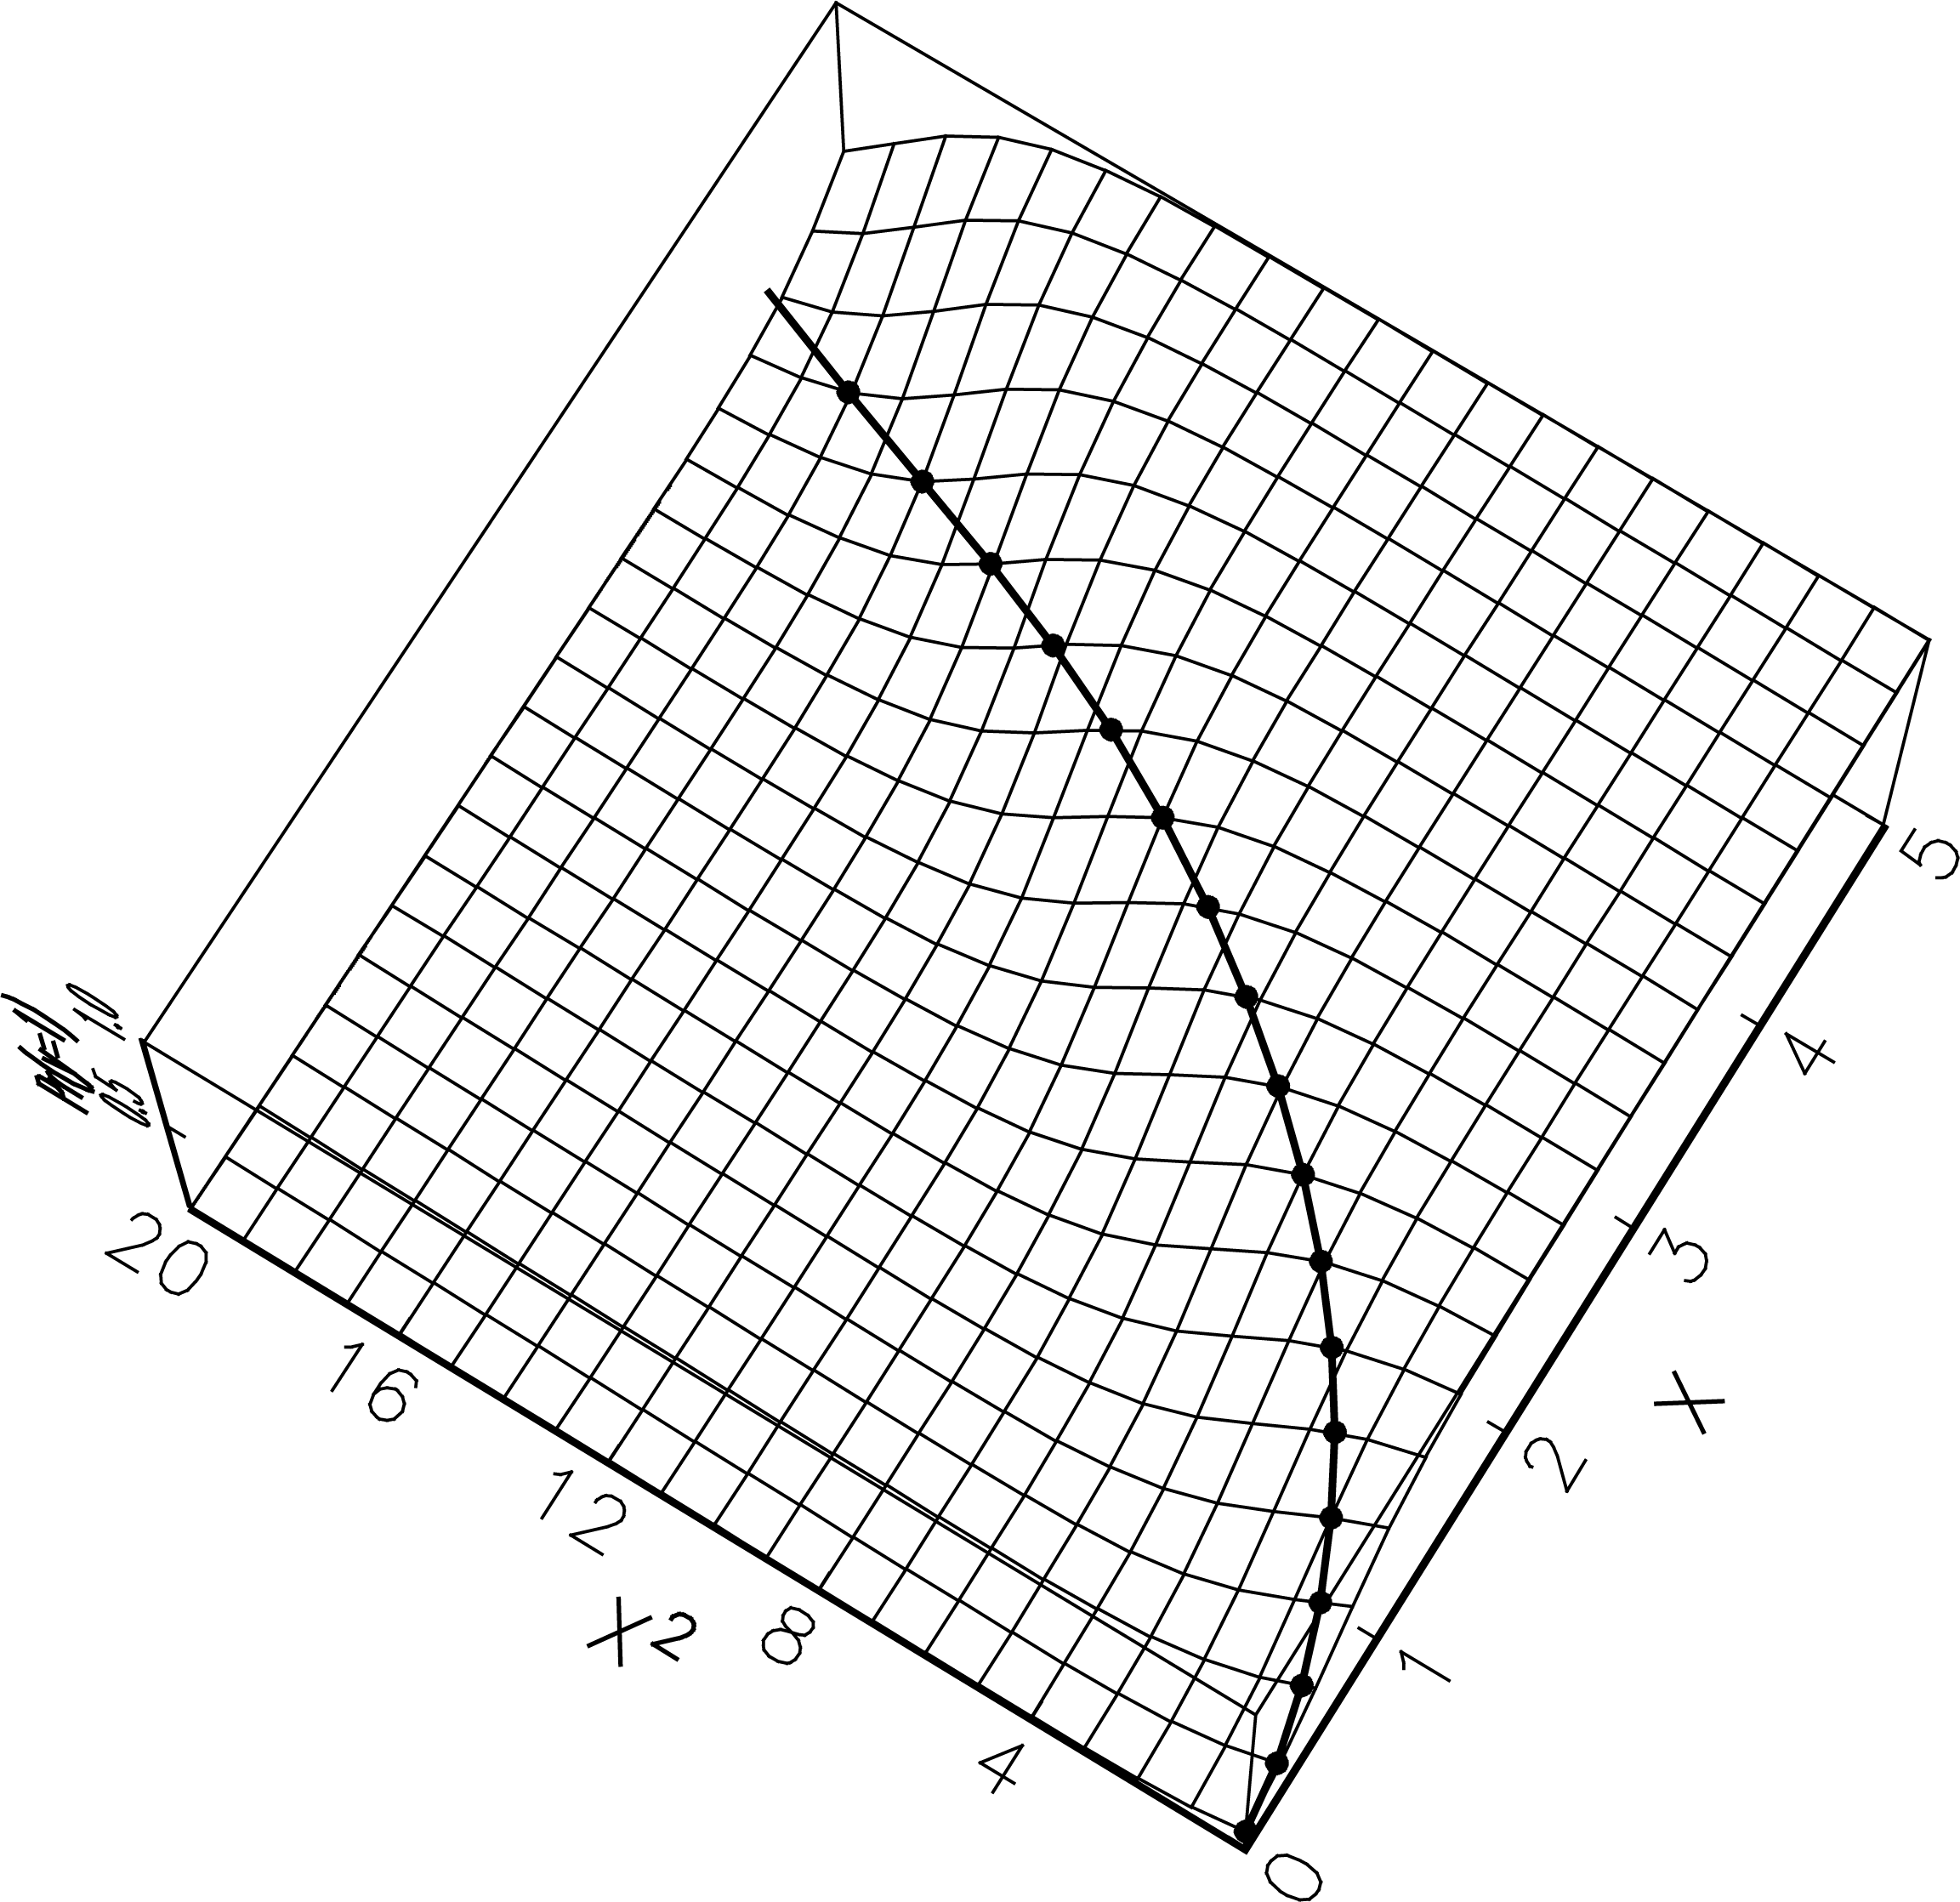

### Leading to

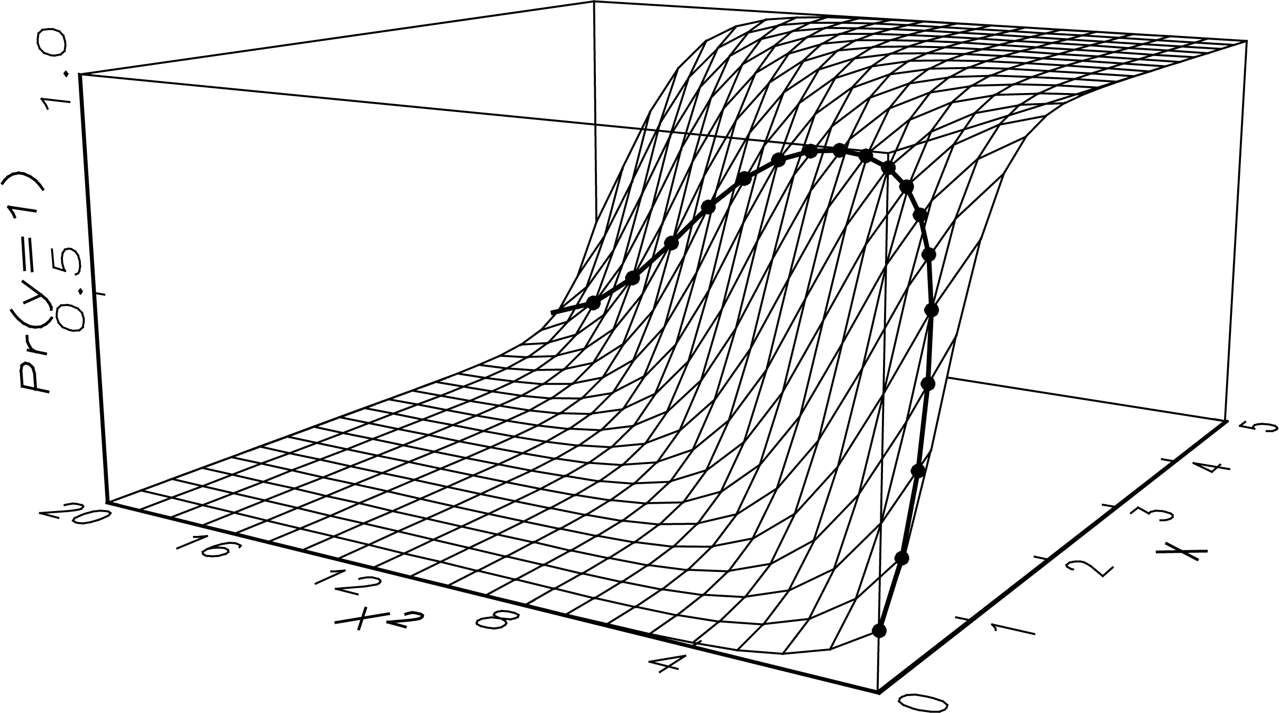

Which margins with factor variables handles with ease.

## Modeling the effect of height and weight on arthritis

logit arthritis c.age i.female i.ed3cat height weight

### The question

Does height "by itself" increase the probability of arthritis?

### The problem

1. Height and weight are linked.

2. Increasing height, holding weight constant is not the question.

3. Allow height to increase and let weight increase a corresponding amount.

* The type of problem has many applications.

### Estimate the model

. sysuse svyhrs3, clear

. svyset secu [pweight=kwgtr], strata(stratum) ///

> vce(linearized) singleunit(missing)

. svy: logit arthritis c.age i.female i.ed3cat height weight

. estimates store lgt

### Predict weight from height

. svy: reg weight height

. local a = \_b[\_con]

. local b = \_b[height]

### Compute std. dev. of height

. svy: mean height

. estat sd

. local sd = el(r(sd),1,1)

. estimates restore lgt

#### Compute predicted probabilities

. mtable, ///

> /// predict at observed

> ///

> at( height=gen(height) ///

> weight=gen(weight)) ///

>

> /// change height only

> ///

> at( height=gen(height+`sd') ///

> weight=gen(weight)) ///

>

> /// change height and weight

> ///

> at( height=gen(height+`sd') ///

weight=gen(`a'+`b'\*(height +`sd')) ) post

Expression: Pr(arthritis)

| pr

----------+---------

1 | 0.570

2 | 0.538

3 | 0.589

#### Discrete changes: mlincom

Instead of lincom \_b[2.\_at] - \_b[1.\_at]

. mlincom 2 - 1, rowname(height\_only)

| lincom pvalue ll ul

--------------+----------------------------------------

height\_only | -0.031 0.000 -0.046 -0.017

. qui mlincom 3 - 1, rowname(and\_weight) add

. mlincom 3 - 2, rowname(2nd\_difference) add

| lincom pvalue ll ul

--------------+----------------------------------------

height\_only | -0.031 0.000 -0.046 -0.017

and\_weight | 0.020 0.008 0.005 0.034

2nd\_differnce | 0.051 0.000 0.046 0.056

# Table with global and local means

## Global means

. sysuse binlfp4, clear

. logit lfp i.wc k5 k618 i.agecat i.hc lwg inc

. qui mtable, atmeans at(wc=0 k5=(0 1 2 3)) estname(NoCol)

. qui mtable, atmeans at(wc=1 k5=(0 1 2 3)) estname(College) ///

> atvars(\_none) right

. mtable, atmeans dydx(wc) at(k5=(0 1 2 3)) estname(Diff) stats(est p) ///

> atvars(\_none) names(columns) right

k5 NoCol College Diff p

------------------------------------------------

0 0.604 0.772 0.168 0.000

1 0.275 0.457 0.182 0.001

2 0.086 0.173 0.087 0.013

3 0.023 0.049 0.027 0.085

. matrix k5wc\_global = \_mtab\_displayed

## Local means

. mtable, over(k5) at(wc=0) estname(NoCol) atmeans atvars(k5)

Expression: Pr(lfp)

| 1. 2. 3. 1.

| wc k5 k618 agecat agecat hc

----------+------------------------------------------------------------

1 | 0 0 1.28 .436 .269 .358

2 | 0 1 1.75 .212 .0169 .517

3 | 0 2 1.31 .0385 0 .538

4 | 0 3 1.33 0 0 1

5 | 1 0 1.28 .436 .269 .358

6 | 1 1 1.75 .212 .0169 .517

7 | 1 2 1.31 .0385 0 .538

8 | 1 3 1.33 0 0 1

|

| lwg inc pr

----------+-----------------------------

1 | 1.11 20 0.583

2 | 1.03 20.8 0.337

3 | 1.18 17.6 0.154

4 | 1.08 46.1 0.017

5 | 1.11 20 0.757

6 | 1.03 20.8 0.530

7 | 1.18 17.6 0.288

8 | 1.08 46.1 0.037

. qui mtable, over(k5) at(wc=1) estname(College) atmeans atvars(\_none) right

. mtable, over(k5) dydx(wc) estname(Diff) atmeans stats(est p) ///

> atvars(\_none) names(columns) right

k5 NoCol College Diff p

------------------------------------------------

0 0.583 0.757 0.173 0.000

1 0.337 0.530 0.193 0.000

2 0.154 0.288 0.134 0.003

3 0.017 0.037 0.020 0.070

. matrix k5wc\_localk5 = \_mtab\_displayed

## Comparing global and local means

| Global | Local | Global - Local

k5 | NoCol Col Diff | NoCol Col Diff | NoCol Col Diff

------+---------------------+---------------------+---------------------

0.00 | 0.60 0.77 0.17 | 0.58 0.76 0.17 | -0.02 -0.02 0.01

1.00 | 0.27 0.46 0.18 | 0.34 0.53 0.19 | 0.06 0.07 0.01

2.00 | 0.09 0.17 0.09 | 0.15 0.29 0.13 | 0.07 0.11 0.05

3.00 | 0.02 0.05 0.03 | 0.02 0.04 0.02 | -0.01 -0.01 -0.01

# Plots with global and local means

If time permits...

## Predictions with global means

. sysuse binlfp4, clear

. logit lfp k5 k618 i.agecat i.wc i.hc lwg inc, nolog

. mgen, at(inc=(0(10)100)) atmeans stub(global\_) predlabel(Global means)

Variables computed by the command:

. margins , at(inc=(0(10)100)) atmeans

Variable Obs Unique Mean Min Max Label

------------------------------------------------------------------------------

global\_pr 11 11 .3608011 .0768617 .7349035 Global means

global\_ll 11 11 .2708139 -.0156624 .6641427 95% lower limit

global\_ul 11 11 .4507883 .1693859 .8056643 95% upper limit

global\_inc 11 11 50 0 100 Family income exclud...

------------------------------------------------------------------------------

## Predictions with local means

. gen inc10k = trunc(inc/10) // income in 10K categories

. mtable, over(inc10k) atmeans stat(est ll ul)

Expression: Pr(lfp)

| 2. 3. 1. 1.

| k5 k618 agecat agecat wc hc

----------+------------------------------------------------------------

1 | .202 1.43 .303 .222 .121 .0808

2 | .261 1.29 .363 .215 .212 .312

:::snip:::

|

| lwg inc pr ll ul

----------+-------------------------------------------------

1 | .922 7.25 0.641 0.584 0.698

2 | 1.08 15.1 0.600 0.559 0.642

:::snip:::

. matrix tab = r(table)

. matrix tab = tab[1...,8..11]

. matrix colnames tab = local\_inc local\_pr local\_ll local\_ul

. svmat tab, names(col)

. label var local\_pr "Local means"

. label var local\_ll "95% lower limit"

. label var local\_ul "95% upper limit"

. label var local\_inc "Family income excluding wife's"

## Comparing global and local predictions

D:\Dropbox\SPost\Work\globalVlocal2.emf

# Beyond the parameters

## Ordinal models are very restrictive

D:\My Box Files\CDA13\Work\lcda13lec-orm-anderson-ordinalmodel-color.emf

## Party identification

. use partyid01, clear

. tab party5, miss

Party: |

1StDem 2Dem |

3Indep 4Rep |

5StRep | Freq. Percent Cum.

------------+-----------------------------------

1\_SD | 266 19.25 19.25

2\_D | 427 30.90 50.14

3\_I | 151 10.93 61.07

4\_R | 369 26.70 87.77

5\_SR | 169 12.23 100.00

------------+-----------------------------------

Total | 1,382 100.00

. nmlab party5 age income black female highschool college

party5 Party: 1StDem 2Dem 3Indep 4Rep 5StRep

age Age

income Income (Thousands of dollars)

black Respondent is black

female Respondent is female

highschool High school is highest degree

college College is highest degree

## ologit of partyid

. ologit party5 age10 income10 i.black i.female i.highschool i.college

. listcoef, help

ologit (N=1382): Factor Change in Odds

Odds of: >m vs <=m (More Republican vs Less Republican)

----------------------------------------------------------------------

party5 | b z P>|z| e^b e^bStdX SDofX

-------------+--------------------------------------------------------

age10 | -0.06359 -2.037 0.042 0.9384 0.8988 1.6783

income10 | 0.09611 4.792 0.000 1.1009 1.3060 2.7781

1.black | -1.47593 -9.824 0.000 0.2286 0.6014 0.3445

1.female | -0.15711 -1.584 0.113 0.8546 0.9244 0.5001

1.highschool | 0.29417 1.943 0.052 1.3420 1.1563 0.4937

1.college | 0.64204 3.543 0.000 1.9004 1.3250 0.4383

----------------------------------------------------------------------

b = raw coefficient

z = z-score for test of b=0

P>|z| = p-value for z-test

e^b = exp(b) = factor change in odds for unit increase in X

e^bStdX = exp(b\*SD of X) = change in odds for SD increase in X

SDofX = standard deviation of X

### Parallel regression assumption

. brant

Brant Test of Parallel Regression Assumption

Variable | chi2 p>chi2 df

-------------+--------------------------

All | 89.84 0.000 18

-------------+--------------------------

age10 | 42.87 0.000 3

income10 | 2.11 0.550 3

1.black | 12.82 0.005 3

1.female | 6.54 0.088 3

1.highschool | 2.92 0.404 3

1.college | 12.24 0.007 3

----------------------------------------

A significant test statistic provides evidence that the parallel

regression assumption has been violated.

Suggestion

1. Results of tests should be clearly explained (like chibar2).

### AME

mchange

dcplot age10 income10, ...

D:\Dropbox\SPost\Work\statcorp-partyid-olm-dcplot.emf

### Probabilities to plot

. mgen, atmeans at(`at\_age') stub(olmage)

Variables computed by the command:

. margins , at(age10=(2(.5)8.5)) atmeans

Variable Obs Unique Mean Min Max Label

------------------------------------------------------------------------------

olmagepr1 14 14 .1773212 .1484803 .2086263 pr(y=1\_SD) from margins

olmagell1 14 14 .1496142 .1213707 .1628012 95% lower limit

olmageul1 14 14 .2050282 .1755899 .2544515 95% upper limit

olmageage10 14 14 5.25 2 8.5 Age in decades

olmageCpr1 14 14 .1773212 .1484803 .2086263 pr(y=1\_SD)

olmagepr2 14 14 .338745 .316049 .3587669 pr(y=2\_D) from margins

olmagell2 14 14 .3092111 .2850512 .3239915 95% lower limit

olmageul2 14 14 .3682789 .3470468 .3935422 95% upper limit

olmageCpr2 14 14 .5160662 .4645293 .5673932 pr(y<=2\_D)

:::snip:::

olmageCpr4 14 14 .8989504 .8792652 .9167384 pr(y<=4\_R)

olmagepr5 14 14 .1010496 .0832616 .1207348 pr(y=5\_SR) from margins

olmagell5 14 14 .082297 .0605158 .0968657 95% lower limit

olmageul5 14 14 .1198021 .1060074 .144604 95% upper limit

olmageCpr5 14 2 1 .9999999 1 pr(y<=5\_SR)

------------------------------------------------------------------------------

. mgen, atmeans at(`at\_inc') stub(olminc)

::: snip :::

### ologit by income

D:\Dropbox\SPost\Work\statcorp-partyid-olm-incProb.emf

### ologit by age

D:\Dropbox\SPost\Work\statcorp-partyid-olm-ageProb.emf

## mlogit of partyid

. mlogit party5 age10 income10 i.black i.female i.highschool i.college

::: snip :::

. mlogtest age10 income10, wald

Wald tests for independent variables (N=1382)

Ho: All coefficients associated with given variable(s) are 0

| chi2 df P>chi2

-------------+-------------------------

age10 | 43.815 4 0.000

income10 | 22.985 4 0.000

---------------------------------------

. listcoef age10 income10

mlogit (N=1382): Factor Change in the Odds of party5

Variable: age10 (sd=1.6783108)

Category 1 : Category 2 | b z P>|z| e^b e^bStdX

--------------------------+---------------------------------------------

1\_SD : 2\_D | 0.23617 4.761 0.000 1.2664 1.4864

1\_SD : 3\_I | 0.31618 4.781 0.000 1.3719 1.7000

1\_SD : 4\_R | 0.24533 4.576 0.000 1.2780 1.5094

1\_SD : 5\_SR | 0.02819 0.438 0.662 1.0286 1.0484

2\_D : 1\_SD | -0.23617 -4.761 0.000 0.7896 0.6728

2\_D : 3\_I | 0.08001 1.287 0.198 1.0833 1.1437

:::snip:::

5\_SR : 4\_R | 0.21714 3.594 0.000 1.2425 1.4397

------------------------------------------------------------------------

Variable: income10 (sd=2.7781476)

:::

. mchange

. local min = log(.1)

. local max = log(3)

. local graphnm "`pgm'-partyid-mnlm-orplot"

. orplot, dc mcolors(`partycolor') min(`min') max(`max').

### mlogit odds ratio plot with ame's

orplot age10 income10, dc

D:\Dropbox\SPost\Work\statcorp-partyid-mnlm-orplot.emf

### mlogit AME

mchange

dcplot age10 income10, std(ss) min(-.06) max(.06) gap(.02) ...

D:\Dropbox\SPost\Work\statcorp-partyid-mnlm-dcplot.emf

### mlogit Probabilities to plot

. mgen, atmeans at(`at\_age') stub(mnlmage)

:::snip:::

. mgen, atmeans at(`at\_inc') stub(mnlminc)

:::snip:::

### mlogit by income

D:\Dropbox\SPost\Work\statcorp-partyid-mnlm-incProb.emf

### ologit by income

D:\Dropbox\SPost\Work\statcorp-partyid-olm-incProb.emf

### mlogit by age

D:\Dropbox\SPost\Work\statcorp-partyid-mnlm-ageProb.emf

### ologit by age

D:\Dropbox\SPost\Work\statcorp-partyid-olm-ageProb.emf

# Post-estimation test & fit

## brant: parallel regression test

## mlogtest, wald or lr

. mlogtest, lr

Likelihood-ratio tests for independent variables (N=337)

Ho: All coefficients associated with given variable(s) are 0

| chi2 df P>chi2

-------------+-------------------------

white | 8.095 4 0.088

ed | 156.937 4 0.000

exper | 8.561 4 0.073

---------------------------------------

Why I'd like this included in the mlogit output...

##### Base BlueCol: 0 significant coefficients

e^b P>|z|

WhiteCol: BlueCol 1.3978 0.720

Prof : BlueCol 1.7122 0.501

Craft : BlueCol 0.4657 0.227

Menial : BlueCol 0.2904 0.088

##### Base Craft: 1 significant coefficient

e^b P>|z|

BlueCol : Craft 2.1472 0.227

WhiteCol: Craft 3.0013 0.179

Prof : Craft 3.6765 0.044

Menial : Craft 0.6235 0.434

##### Base Menial: 1 significant coefficient

e^b P>|z|

Craft : Menial 1.6037 0.434

BlueCol : Menial 3.4436 0.088

WhiteCol: Menial 4.8133 0.082

Prof : Menial 5.8962 0.019

##### Base Prof: 2 significant coefficients

e^b P>|z|

WhiteCol: Prof 0.8163 0.815

BlueCol : Prof 0.5840 0.501

Craft : Prof 0.2720 0.044

Menial : Prof 0.1696 0.019

##### Base WhiteCol: 0 significant coefficients

e^b P>|z|

------------------+-------------------

Prof : WhiteCol 1.2250 0.815

BlueCol : WhiteCol 0.7154 0.720

Craft : WhiteCol 0.3332 0.179

Menial : WhiteCol 0.2078 0.082

## mlogtest, combine

Testing if outcome categories are significantly differentiated.

## mlogtest, iia

Various not very useful but highly requested IIA tests.

## countfit: borrowed by SAS's countreg

. countfit art fem mar kid5 phd ment, gen(cfeg) replace ///

> inflate(fem mar kid5 phd ment) maxcount(6) ///

----------------------------------------------------------------------

Variable | Base\_PRM Base\_NBRM Base\_ZIP

---------------------------------+------------------------------------

art |

Gender: 1=female 0=male | 0.799 0.805 0.811

| -4.11 -2.98 -3.30

Married: 1=yes 0=no | 1.168 1.162 1.109

| 2.53 1.83 1.46

Number of children < 6 | 0.831 0.838 0.866

| -4.61 -3.32 -3.02

PhD prestige | 1.013 1.015 0.994

| 0.49 0.42 -0.20

Article by mentor in last 3 yrs | 1.026 1.030 1.018

| 12.73 8.38 7.89

Constant | 1.356 1.292 1.898

| 2.96 1.85 5.28

---------------------------------+------------------------------------

lnalpha |

Constant | 0.442

| -6.81

And so on for all models...

Comparison of Mean Observed and Predicted Count

Maximum At Mean

Model Difference Value |Diff|

---------------------------------------------

PRM 0.091 0 0.026

NBRM -0.015 3 0.006

ZIP 0.054 1 0.015

ZINB -0.019 3 0.008

PRM: Predicted and actual probabilities

Count Actual Predicted |Diff| Pearson

------------------------------------------------

0 0.301 0.209 0.091 36.489

1 0.269 0.310 0.041 4.962

2 0.195 0.242 0.048 8.549

3 0.092 0.135 0.043 12.483

4 0.073 0.061 0.012 2.174

5 0.030 0.025 0.005 0.760

6 0.019 0.010 0.009 6.883

7 0.013 0.004 0.009 17.815

8 0.001 0.002 0.001 0.300

9 0.002 0.001 0.001 1.550

------------------------------------------------

Sum 0.993 0.999 0.259 91.964

And so on for all models summarized as a graph...

D:\My Box Files\CDA13\Work\lecture-do\crm-couart\cda13lec-crm-couart-countfit-plot.emf

Tests and Fit Statistics

PRM BIC= 3343.026 AIC= 3314.113 Prefer Over Evidence

-------------------------------------------------------------------------

vs NBRM BIC= 3169.649 dif= 173.377 NBRM PRM Very strong

AIC= 3135.917 dif= 178.196 NBRM PRM

LRX2= 180.196 prob= 0.000 NBRM PRM p=0.000

-------------------------------------------------------------------------

vs ZIP BIC= 3291.373 dif= 51.653 ZIP PRM Very strong

AIC= 3233.546 dif= 80.567 ZIP PRM

Vuong= 4.180 prob= 0.000 ZIP PRM p=0.000

-------------------------------------------------------------------------

vs ZINB BIC= 3188.628 dif= 154.398 ZINB PRM Very strong

AIC= 3125.982 dif= 188.131 ZINB PRM

-------------------------------------------------------------------------

NBRM BIC= 3169.649 AIC= 3135.917 Prefer Over Evidence

-------------------------------------------------------------------------

vs ZIP BIC= 3291.373 dif= -121.724 NBRM ZIP Very strong

AIC= 3233.546 dif= -97.629 NBRM ZIP

-------------------------------------------------------------------------

vs ZINB BIC= 3188.628 dif= -18.979 NBRM ZINB Very strong

AIC= 3125.982 dif= 9.935 ZINB NBRM

Vuong= 2.242 prob= 0.012 ZINB NBRM p=0.012

-------------------------------------------------------------------------

ZIP BIC= 3291.373 AIC= 3233.546 Prefer Over Evidence

-------------------------------------------------------------------------

vs ZINB BIC= 3188.628 dif= 102.745 ZINB ZIP Very strong

AIC= 3125.982 dif= 107.564 ZINB ZIP

LRX2= 109.564 prob= 0.000 ZINB ZIP p=0.000

## fitstat

These are generally not very useful, so don't waste time computing them...

. fitstat

Measures of Fit for logit of lfp

Log-Lik Intercept Only: -514.873 Log-Lik Full Model: -452.724

D(744): 905.447 LR(8): 124.299

Prob > LR: 0.000

McFadden's R2: 0.121 McFadden's Adj R2: 0.103

ML (Cox-Snell) R2: 0.152 Cragg-Uhler(Nagelkerke) R2: 0.204

McKelvey & Zavoina's R2: 0.215 Efron's R2: 0.153

Tjur's Discrimination Coef: 0.153

Variance of y\*: 4.192 Variance of error: 3.290

Count R2: 0.676 Adj Count R2: 0.249

AIC: 923.447 AIC/N: 1.226

BIC: 965.064 k: 9.000

## ic compare

. logit lfp i.wc k5 k618 age i.hc lwg inc

. fitstat, ic saving(nofv)

. logit lfp i.wc k5 k618 i.agecat i.hc lwg inc

. fitstat, ic using(nofv) dif

Current nofv Difference

Model: logit logit

N: 753 753 0

AIC 923.447 921.266 2.181

AIC/N 1.226 1.223 0.003

BIC 965.064 958.258 6.805

k 9.000 8.000 1.000

BIC (deviance) -4022.857 -4029.663 6.805

BIC' -71.307 -78.112 6.805

Difference of 6.805 in BIC provides strong support for saved model.

Suggestion

1. A "lrtest" like command for use with IC measures.

## Listing coefficients

. listcoef, help

zip (N=915): Factor Change in Expected Count

Observed SD: 1.926069

Count Equation: Factor Change in Expected Count for Those Not Always 0

----------------------------------------------------------------------

art | b z P>|z| e^b e^bStdX SDofX

-------------+--------------------------------------------------------

fem | -0.20914 -3.299 0.001 0.8113 0.9010 0.4987

mar | 0.10375 1.459 0.145 1.1093 1.0503 0.4732

kid5 | -0.14332 -3.022 0.003 0.8665 0.8962 0.7649

phd | -0.00617 -0.199 0.842 0.9939 0.9939 0.9842

ment | 0.01810 7.886 0.000 1.0183 1.1872 9.4839

----------------------------------------------------------------------

b = raw coefficient

z = z-score for test of b=0

P>|z| = p-value for z-test

e^b = exp(b) = factor change in expected count for unit increase in X

e^bStdX = exp(b\*SD of X) = change in expected count for SD increase in X

SDofX = standard deviation of X

Binary Equation: Factor Change in Odds of Always 0

----------------------------------------------------------------------

Always0 | b z P>|z| e^b e^bStdX SDofX

-------------+--------------------------------------------------------

fem | 0.10975 0.392 0.695 1.1160 1.0563 0.4987

mar | -0.35401 -1.115 0.265 0.7019 0.8458 0.4732

kid5 | 0.21710 1.105 0.269 1.2425 1.1806 0.7649

phd | 0.00127 0.009 0.993 1.0013 1.0013 0.9842

ment | -0.13411 -2.964 0.003 0.8745 0.2803 9.4839

----------------------------------------------------------------------

b = raw coefficient

z = z-score for test of b=0

P>|z| = p-value for z-test

e^b = exp(b) = factor change in odds for unit increase in X

e^bStdX = exp(b\*SD of X) = change in odds for SD increase in X

SDofX = standard deviation of X

# Suggestion

## margins related

1. More compact output.
2. Multiple outcomes in same estimation.
3. Save individual observations: margins, gen()
4. Let predict predict everything that margins can estimate
5. margins, at(x=gen(x+sd(x)): egen() for at()
6. marginsplot: save graphing variables and allow multiple outcomes
7. margins, autopost: automatically save current estimation command if it is in memory; if not in memory, load the one that was autoposted.
8. Better ways to incorporate local predictions: over(x=gen())?

## Data analysis

1. A unified method for collecting results.
2. lrtest type command for ic
3. vuong function to compare models.
4. datasignature to detect all changes (controlled by save and use)
5. sem: LCA

## Really useful that seem easy

1. tab with variable name and variable label; values with value labels.
2. svy: means for fv's
3. reallyclearall
4. fastcd by Nick Winter

## Programming

1. Better tools for factor variables (or let Jeff make house calls)

* factor variables have greatly increased the barrier to user written commands.

1. r(table) for all commands with all key results (e.g., lincom)
2. Stronger controls for value labels

## Graphics

1. 3d wireframe graphics

## For workflow

1. help mix not help me!

## Move the best functions of SPost into Stata

# Thank you

Contents

[Interpreting regression models 1](#_Toc363647354)

[Working with StataCorp 2](#_Toc363647355)

[Continuing work... 3](#_Toc363647356)

[Stata at Indiana 4](#_Toc363647357)

[Goals for visiting StataCorp 5](#_Toc363647358)

[Demo SPost13 wrappers for margins 5](#_Toc363647359)

[Other SPost13 commands 5](#_Toc363647360)

[Things we'd like to see in Stata 5](#_Toc363647361)

[Interpretation using predictions 6](#_Toc363647362)

[Interpreting nonlinear models 7](#_Toc363647363)

[Ways to use predictions 7](#_Toc363647364)

[The tools 8](#_Toc363647365)

[Official Stata 8](#_Toc363647366)

[SPost13 wrappers for margins and lincom 8](#_Toc363647367)

[Why not simply use margins and marginsplot? 8](#_Toc363647368)

[Tables of predictions 9](#_Toc363647369)

[Binary outcome 9](#_Toc363647370)

[Categorical outcomes 14](#_Toc363647371)

[Marginal effects 20](#_Toc363647372)

[Marginal change 21](#_Toc363647373)

[Discrete change 21](#_Toc363647374)

[Binary outcome 22](#_Toc363647375)

[Question 22](#_Toc363647376)

[mchange with options (edited) 24](#_Toc363647377)

[Ordinal outcomes 27](#_Toc363647378)

[What logit output might look like 32](#_Toc363647379)

[AME and MEM 33](#_Toc363647380)

[MEM 33](#_Toc363647381)

[AME 33](#_Toc363647382)

[Should you replace one mean with another? 33](#_Toc363647383)

[Distribution of ME's 34](#_Toc363647384)

[Marginal change for income 34](#_Toc363647385)

[Discrete change for woman attending college 35](#_Toc363647386)

[Linked marginal effects 37](#_Toc363647387)

[Age and age-squared are strongly linked 38](#_Toc363647388)

[Leading to 39](#_Toc363647389)

[Modeling the effect of height and weight on arthritis 40](#_Toc363647390)

[The question 40](#_Toc363647391)

[The problem 40](#_Toc363647392)

[Estimate the model 41](#_Toc363647393)

[Predict weight from height 41](#_Toc363647394)

[Compute std. dev. of height 41](#_Toc363647395)

[Table with global and local means 44](#_Toc363647396)

[Global means 44](#_Toc363647397)

[Local means 45](#_Toc363647398)

[Comparing global and local means 47](#_Toc363647399)

[Plots with global and local means 48](#_Toc363647400)

[Predictions with global means 48](#_Toc363647401)

[Predictions with local means 49](#_Toc363647402)

[Comparing global and local predictions 50](#_Toc363647403)

[Beyond the parameters 51](#_Toc363647404)

[Ordinal models are very restrictive 51](#_Toc363647405)

[Party identification 52](#_Toc363647406)

[ologit of partyid 53](#_Toc363647407)

[Parallel regression assumption 54](#_Toc363647408)

[AME 55](#_Toc363647409)

[ologit by income 56](#_Toc363647410)

[ologit by age 57](#_Toc363647411)

[mlogit of partyid 58](#_Toc363647412)

[mlogit odds ratio plot with ame's 60](#_Toc363647413)

[mlogit AME 61](#_Toc363647414)

[mlogit Probabilities to plot 62](#_Toc363647415)

[mlogit by income 63](#_Toc363647416)

[ologit by income 64](#_Toc363647417)

[mlogit by age 65](#_Toc363647418)

[ologit by age 66](#_Toc363647419)

[Post-estimation test & fit 67](#_Toc363647420)

[brant: parallel regression test 67](#_Toc363647421)

[mlogtest, wald or lr 67](#_Toc363647422)

[mlogtest, combine 69](#_Toc363647423)

[mlogtest, iia 69](#_Toc363647424)

[countfit: borrowed by SAS's countreg 70](#_Toc363647425)

[fitstat 74](#_Toc363647426)

[ic compare 75](#_Toc363647427)

[Listing coefficients 76](#_Toc363647428)

[Suggestion 78](#_Toc363647429)

[margins related 78](#_Toc363647430)

[Data analysis 79](#_Toc363647431)

[Really useful that seem easy 79](#_Toc363647432)

[Programming 80](#_Toc363647433)

[Graphics 80](#_Toc363647434)

[For workflow 80](#_Toc363647435)

[Move the best functions of SPost into Stata 80](#_Toc363647436)

[Thank you 81](#_Toc363647437)